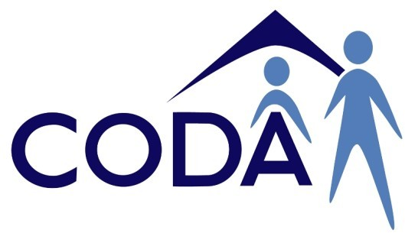
Need more help?

CORAS — Colac Otway Regional Advocacy Services.
You can call Paul at his office on

Advocacy

5232 1009

You can visit their office at 50A Rae Street, Colac.

or
Assert 4 All — Barwon Disability Resource Council.
You can call them on 5221 8011.

You can visit their office at 48 McKillop Street, Geelong.

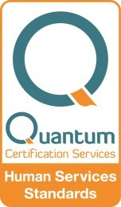or
Issued:25/01/2018

Or write to us by mailing your letter to:
CODA Inc.
P.O. Box 370 Colac 3250.
Or visit us at shop 6, 58 Hesse Street,
Colac .
You can call the CODA Inc. office
on 5231 1573

Contact Us

Valid — Victorian Advocacy League for individuals with Disability Inc.
You can call their office on 9416 4003

You can visit their office at 235 Napier Street, Fitzroy.

Colac Otway Disability Accommodation Inc.

What is an advocate?

An advocate is someone who can speak on your behalf.

An advocate can help you:

- Maintain your rights.
- Help you make decisions that affect you.

- With problems or complaints about services (for example
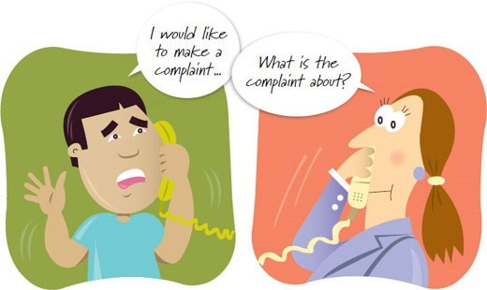
CODA, Day Programs, Doctors).

When might you need an
advocate?

- When making a complaint about a service.

- If you feel you have not been treated fairly.

- Talking to a doctor about your treatment.
- Talking to your bank about the types of accounts you need.

- Talking to Centrelink about your payments.

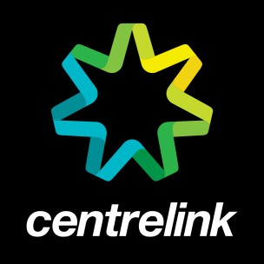

- Talking to your boss about your job.

Who can be your advocate?
  - Someone from an advocacy service, like Paul Brady.
  - A support person.

  - A friend.

  - A family member or relative.

  - A neighbour

  - A teacher.

Someone you trust.

You can ask someone from CODA Inc. to help you find an advocate.
Sure
Can you help me find someone to help me?

