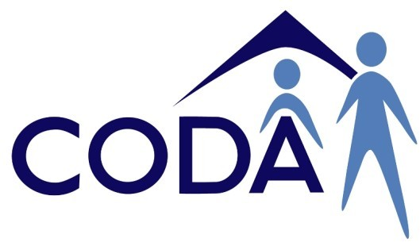
Need more help?

CORAS — Colac Otway Regional Advocacy Services.
You can call Paul or Jess at the their office on 5232 1009

Privacy
You can visit their office at 50A Rae Street, Colac.

or
Assert 4 All — Barwon Disability Resource Council.
You can call them on 5221 8011.

You can visit their office at 48 McKillop Street, Geelong.

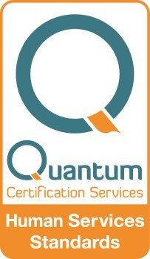or
Issued:20/05/2020

Or write to us by mailing your letter to: CODA Inc.
P.O. Box 370
Colac 3250.
Or visit us at shop 6, 58 Hesse Street,
Colac .
You can call the CODA Inc. office
on 5231 1573

Contact Us

Valid — Victorian Advocacy League for individuals with Disability Inc.
You can call their office on 9416 4003

You can visit their office at 235 Napier Street, Fitzroy.

Colac Otway Disability Accommodation Inc.

Privacy

CODA Inc. keeps your personal information safe by:

- locking cabinets where your information is kept.

- having passwords on computers.

- using computer programs to prevent access to people other than CODA staff.

Sharing information

If we need to give your information to someone we will:

- check if we have general permission.

- ask your permission where not already given.

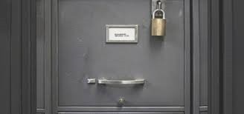
- sometimes we have to give information to government departments, such as your funding body or Victoria Police, whether you give permission or not. They also have to keep your information private.
If you need more information you can contact the Office of the Australian Information Commissioner, who helps protect your privacy.

You can call the enquiry line on 1300 363 992 and ask them to help you with your problem.
Or visit www.oaic.gov.au

Complaints?

If you are unhappy with the way we have used or stored your information please contact the CODA Inc. office on 5231 1573 and ask to speak to the
Quality and Compliance Officer, or call the NDIS Quality and Safeguards Commission on 1800 035 544.

Making a complaint is ok

